1. Configure private interface of the server with a static IP address, use the first address from the IP network: 192.168.100.0/24.

2. After install the base system, use VI to configure hostname as server1 and domain “YourName . local”, so the FQDN of the server will be server1.yourname. local

3. Configure client1 hostname as client1 and FQDN as client1.yourname. local

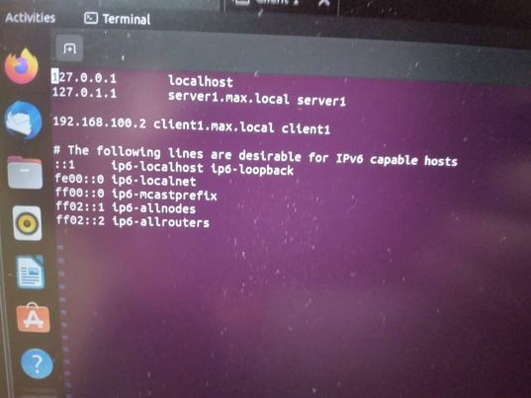

4. Install and configure DHCP protocol on the server1, make sure the Client1 private interface will get an IPv4 address, Default Gateway and Domain Name and DNS automatically from DHCP on server1. (The Default Gateway, DNS name server is server1 IP address).

sudo apt install isc-dhcp-server

sudo vi /etc/dhcp/dhcpd.conf

option domain-name "tecmint.lan";

option domain-name-servers ns1.tecmint.lan, ns2.tecmint.lan;

default-lease-time 3600;

max-lease-time 7200;

authoritative;

5. Install and Configure DNS on server for the internal network so hostnames are resolved to IP addresses.

sudo apt-get install bind9

sudo apt-get install bind9

sudo vi /etc/bind/named.conf.options

forwarders {

8.8.8.8;

};

sudo systemctl restart bind9

6. Create (comma separated values) CSV file with the following user attributes:

FirstName, LastName, UserName, Department and Password.

sudo touch users.cvs

sudo nano users.cvs

(input the users information)

FirstName,LastName,UserName,Department,Password,

Alexander,Ragnarsson,alr,IT,Pass123

Andrea,Klara,ank,IT,Pass123

Guðmundur,Steindórsson,gus,Management,Pass123

Halldór,Jónsson,haj,Management,Pass123

Hrannar,Arason,hra,Accounting,Pass123

Ingibjörg,Guðlaugsdótti, ing,Accounting,Pass123

Ísak,Leifsson,isl,Manufacturing,Pass123

Jóhanna,Hafsteinsdóttir,joh,Manufacturing,Pass123

Kristján,Svanbergsson,krs,Manufacturing,Pass123

Lárus,Gunnarsson,lag,Manufacturing,Pass123

Linda,Magnúsdótti, lim,Manufacturing,Pass123

Sigrún,Jensdóttir,sij,Manufacturing,Pass123

(save it)

7. Create a bash script that will import all user accounts into their groups respectively.

sudo vi addusers.sh

#!/usr/bin/bash

myinput=”/home/server1/users.cvs”

declare -a fname

declare -a lname

declare -a user

declare -a dept

declare -a pass

while IFS=, read -r FirstName LastName UserName Department Password;

do

fname+=(“$FirstName”)

name+=(“$LastName”)

user+=(“$UserName”)

dept+=(“$Department”)

pass+=(“$Password”)

done<$myinput

for index in “${!user[@]}”;

do

sudo groupadd “${dept[$index]}”;

sudo useradd -g “${dept[$index]}” \

-d “/home/${user[$index]}” \

-s “/bin/bash” \

-p “$(echo “${pass[$index]}” | openssl passwd -1 -stdin) “ “${user[$index]}”

done

(save it)

sudo chmod +x addusers.sh

8. Each user should have his own directory under /home should use bash shell and an encrypted password.

sudo mkhomedir_helper alr

sudo mkhomedir_helper ank

sudo mkhomedir_helper gus

sudo mkhomedir_helper haj

sudo mkhomedir_helper hra

sudo mkhomedir_helper ing

sudo mkhomedir_helper isl

sudo mkhomedir_helper joh

sudo mkhomedir_helper krs

sudo mkhomedir_helper lag

sudo mkhomedir_helper lim

sudo mkhomedir_helper sij

9.All users should have access to their home directory only, except the for the IT group they should have full access to all directories.

10.Install configure Samba then create network shared folder for each department. All users should have full access (Read, Write and Execute Permissions) to their shared Folder. However, IT and Management should full access to all shared Folders

sudo mkdir -p /home/it

sudo chgrp IT /home/it

sudo chmod -770

sudo chgrp Management /home/it

sudo chmod -770

sudo mkdir -p /home/management

sudo chgrp IT /home/management

sudo chmod -770

sudo chgrp Management /home/management

sudo chmod -770

sudo mkdir -p /home/accounting

sudo chgrp IT /home/accounting

sudo chgrp Management /home/accounting

sudo chmod -770

sudo chgrp Accounting/home/accounting

sudo chmod -770

sudo mkdir -p /home/manufacturing

sudo chgrp IT /home/manufacturing

sudo chgrp Management /home/manufacturing

sudo chmod -770

sudo chgrp Manufacturing/home/manufacturing

sudo chmod -770

sudo apt update

sudo apt install samba

sudo mv /etc/samba/smb.conf

sudo nano /etc/samba/smb.conf

path = /opt/editorial

browsable = yes

writable = yes

guest ok = yes

read only = no

valid users = @editorial

(save it)

.